Frodsham CE Primary School Long Term Plan 2023/2024 Reception
Love each other as God loves us.
 | Autumn |  |  | Spring |  |  | Summer
Christian  Values | Love | Respect |  | Kindness | Community |  | Faith | Resilience
RE  (Year A)  Several visits to be made to St  Laurence’s Church throughout the year. | Creation  What does the creation story teach Christians about God?  I can talk about how Christians believe that God  created the world and thought it was good.  I can talk about how Christians believe that the world and everything in it belongs to God and humans should take care of it.  Incarnation  Why do Christians perform nativity plays at Christmas?  Why do Christians give and receive presents at Christmas?  Why do Christians say Jesus is special?  I can retell the Christmas story simply.  I can talk about how nativity plays help Christians remember and celebrate the birth of Jesus. |  |  | Old Testament Stories  What do the stories of the Old Testament teach us about God?  I can begin to talk about stories from the Bible and what these teach us about God.  Specified stories to be shared:  Noah  Moses’ Birth  Joseph’s Coat  David and Goliath  Daniel and the Lions  Jonah  Discipleship  Why did the first disciples change their lives when they met Jesus?  I can describe three changes that happened to the disciples after they met Jesus.  I can talk about why the disciples changed their lives when they met Jesus.  I can talk about the impact Jesus made on the disciples.  Easter/Forgiveness  Why do people say sorry?  Why do Christians say, ‘it doesn’t matter when people make mistakes?’  Why do Christians put three crosses in an Easter garden?  I can say why the words ‘sorry’ and ‘apologise’ might be important to Christians.  I can say what Jesus may have been meaning when he said ‘turn the other cheek’.  I can explain what an Easter garden is and why Christians might put 3 crosses in it. |  |  | Miracles of Jesus  What do the miracles teach us about God’s and Jesus’ power?  I can begin to talk about stories from the Bible and what these teach us about God and Jesus.  Parables of Jesus  How do the parables teach us to live as God and Jesus would want us to?  I can begin to talk about stories from the Bible and what these teach us about how God and Jesus want people to live.
 | World Faith Celebrations – teach as they occur across the year - What do other people believe? Is it the same or different to Christianity?
RE  (Year B)  Several visits to be made to St  Laurence’s Church throughout the year. | Love each other as God loves us  What does the creation story teach Christians about God’s love for all?  I can explain what the school vision ‘Love as God  loves us’ means.  I can talk about how Christians believe that God  created the world as a way of showing his love  for us.  I can talk about how Christians believe that the world and everything in it belongs to God and humans should love and take care of it.  Incarnation  Why do Christians perform nativity plays at Christmas?  Why do Christians give and receive presents at  Christmas?  Why do Christians say Jesus is special?  I can retell the Christmas story simply.  I can talk about how nativity plays help Christians remember and celebrate the birth of Jesus. |  |  | Old Testament Stories  What do the stories of the Old Testament teach us about God?  I can begin to talk about stories from the Bible and what these teach us about God.  Specified stories  to be shared:  Noah  Moses’ Birth  Joseph’s Coat  David and Goliath  Daniel and the Lions  Jonah  Holy Spirit  Easter/Forgiveness  Why do people say sorry?  Why do Christians say, ‘it doesn’t matter when people make mistakes?’  Why do Christians put three crosses in an Easter  Garden?  I can say why the words ‘sorry’ and ‘apologise’  might be important to Christians.  I can say what Jesus may have been meaning  when he said ‘turn the other cheek’.  I can explain what an Easter garden is and why Christians might put 3 crosses in it. |  |  | Miracles of Jesus  What do the miracles teach us about God’s and Jesus’ power?  I can begin to talk about stories from the Bible and what these teach us about God and Jesus.  Parables of Jesus  How do the parables teach us to live as God and Jesus would want us to?  I can begin to talk about stories from the Bible and what these teach us about how God and Jesus want people to live.
 | Autumn 1 |  | Autumn 2 | Spring 1 |  | Spring 2 | Summer 1 | Summer 2
General Themes  These themes may be adapted at various points to allow for children’s interests to flow through the  Provision. | All about me |  | Let’s tell a story | Journeys |  | Eggs, eggs, eggs! | Superheroes | All creatures great and small
Characteristics of Effective Learning  Over Arching Principles  Play | Playing and exploring: - Children investigate and experience things, and ‘have a go’. Children who actively participate in their own play develop a larger store of information and experiences to draw on which positively supports their learning.  Active learning: - Children concentrate and keep on trying if they encounter difficulties. They are proud of their own achievements. For children to develop into self-regulating, lifelong learners they are required to take ownership, accept challenges, and learn persistence. Creating and thinking critically: - Children develop their own ideas and make links between these ideas. They think flexibly and rationally, drawing on previous experiences which help them to solve problems and reach conclusions.  Unique Child: Every child is unique and has the potential to be resilient, capable, confident and self-assured.  Positive Relationships: Children flourish with warm, strong & positive partnerships between all staff and parents/carers. This promotes independence across the EYFS curriculum.  Enabling environments: Children learn and develop well in safe and secure environments where routines are established and where adults respond to their individual needs and help them to build upon their learning over time.  Learning and Development: Children develop and learn at different rates. We will support all children no matter where they are in their learning journey.  PLAY: In Reception, we understand that children learn best when they are absorbed, interested and active. We understand that active learning involves other children, adults, objects, ideas, stimuli and events that aim to engage and involve children for sustained periods. We believe that Early Years education should be as practical as possible. PLAY is essential for children’s development across all areas. Play builds on children’s confidence as they learn to explore, to relate to others around them and develop relationships, set their own goals and solve problems. Children learn by leading their own play and by taking part in play which is guided by adults.

 | Autumn 1 | Autumn 2 | Spring 1 | Spring 2 | Summer 1 | Summer 2
General Themes | All about me | Let’s tell a story | Journeys | Eggs, eggs, eggs! | Superheroes | All creatures great and small
Communication and Language  Whole EYFS Focus – C&L is developed throughout the year through high quality interactions, daily group discussions, PSHE times, stories, singing, Helicopter Stories, assemblies. | The development of children’s spoken language underpins all seven areas of learning and development. Children’s back-and-forth interactions from an early age form the foundations for language and cognitive development. The number and quality of the conversations they have with adults and peers throughout the day in a language-rich environment is crucial. By commenting on what children are interested in or doing and echoing back what they say with new vocabulary added, practitioners will build children's language effectively. Reading frequently to children, and engaging them actively in stories, non-fiction, rhymes and poems, and then providing them with extensive opportunities to use and embed new words in a range of contexts, will give children the opportunity to thrive. Through conversation, storytelling and role play, where children share their ideas with support and modelling from their teacher, and sensitive questioning that invites them to elaborate, children become comfortable using a rich range of vocabulary and language structures.
Listening, attention and understanding  Speaking | Settling in activities. Making friends. Children talking about experiences that are familiar to them. Sharing facts about me.  Model talk routines through the day. For example, arriving in school: “Good morning, how are you?”  Show and Tell time. | Settling in activities. Develop vocabulary. Narrating stories. Performing stories. Following instructions.  Takes part in discussions. Understand how to listen carefully and why listening is important.  Use new vocabulary through the day. Choose books that will develop their vocabulary.  Show and Tell time. | Using language well. Ask how and why questions…  Ask questions to find out more and to check they understand what has been said to them. Describe events in some detail.  Listen to and talk about stories to build familiarity and understanding.  Learn rhymes, poems and songs.  Show and Tell time. | Settling in activities Describe events in detail –time connectives.  Understand how to listen carefully and why listening is important.  Use picture cue cards to talk about an object: “What colour is it? Where would you find it?  Sustained focus when listening to a story.  Show and Tell time. | Settling in activities Re-read some books so children learn the language necessary to talk about what is happening in each illustration and relate it to their own lives.  Show and Tell time. | Read aloud books to children that will extend their knowledge of the world and illustrate a current topic.  Select books containing photographs and pictures.  Show and Tell time.
 | Autumn 1 | Autumn 2 | Spring 1 | Spring 2 | Summer 1 | Summer 2
General Themes | All about me | Let’s tell a story | Journeys | Eggs, eggs, eggs! | Superheroes | All creatures great and small
Personal, Social and Emotional Development | Children’s personal, social and emotional development (PSED) is crucial for children to lead healthy and happy lives and is fundamental to their cognitive development. Underpinning their personal development are the important attachments that shape their social world. Strong, warm and supportive relationships with adults enable children to learn how to understand their own feelings and those of others. Children should be supported to manage emotions, develop a positive sense of self, set themselves simple goals, have confidence in their own abilities, to persist and wait for what they want and direct attention as necessary. Through adult modelling and guidance, they will learn how to look after their bodies, including healthy eating, and manage personal needs independently. Through supported interaction with other children, they learn how to make good friendships, co-operate, and resolve conflicts peaceably. These attributes will provide a secure platform from which children can achieve at school and in later life.
Managing Self  Self-Regulation | School and class Rules and Routines  Behaviour chart  Supporting children to build relationships  Making friends  Taking turns and sharing  Safe place  Tidying up routines  Identifying their family.  Commenting on photos of their family; naming who they can see and of what relation they are to them.  Can draw similarities and make comparisons between other families? | Self - Confidence  Recognising and naming feelings  Begin to show resilience  Express likes/ dislikes | Talking about character’s emotions  How to deal with Emotions  Talk with others to solve conflicts | Helping others to solve conflicts | Moderate feelings socially and emotionally  Model good hygiene practices  See themselves as valuable individuals  Build constructive and respectful relationships  Being respectful  Diversity - families | Keeping healthy Making healthy food choices
No Outsiders  Everyone different, everyone welcome. | 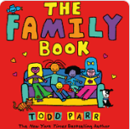  All families are different | 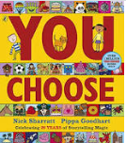  To choose what I like. | 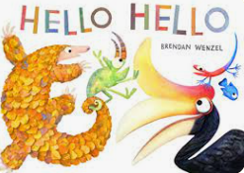  To say hello | 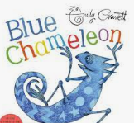  To make a new friend. | 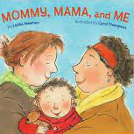  To celebrate my family. | 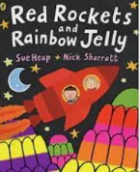  It’s ok to like different things.
Progression into Year 1 | Relationships:  I can share how I feel  I know which parts of my body are private  I can tell you about special people in my life  I can share my views with others I show respect for others  I understand that there are different types of families  I know what makes a good friend I value difference |  |  | Health and well-being:  I know what keeps our bodies healthy  I know how to keep clean  I recognise what I am good at and can set a target  I know how to play safely at home  I know how to ask for help when I need it
 | Autumn 1 | Autumn 2 | Spring 1 | Spring 2 | Summer 1 | Summer 2
General Themes | All about me | Let’s tell a story | Journeys | Eggs, eggs, eggs! | Superheroes | All creatures great and small
Physical Development  Fine motor  Continuously check the process of children’s handwriting (pencil grip and letter formation, including directionality). Provide extra help and guidance when needed.  Daily opportunities for Fine Motor Activities  Gross motor  Funky fingers Activities  Dough disco  Squiggle | Physical activity is vital in children’s all-round development, enabling them to pursue happy, healthy and active lives. Gross and fine motor experiences develop incrementally throughout early childhood, starting with sensory explorations and the development of a child’s strength, co-ordination and positional awareness through tummy time, crawling and play movement with both objects and adults. By creating games and providing opportunities for play both indoors and outdoors, adults can support children to develop their core strength, stability, balance, spatial awareness, co-ordination and agility. Gross motor skills provide the foundation for developing healthy bodies and social and emotional well-being. Fine motor control and precision helps with hand-eye co-ordination, which is later linked to early literacy. Repeated and varied opportunities to explore and play with small world activities, puzzles, arts and crafts and the practice of using small tools, with feedback and support from adults, allow children to develop proficiency, control and confidence.
 | Threading, cutting, weaving, playdough. Fine Motor activities. Manipulate objects with good fine motor skills.  Draw lines and circles using gross motor movements.  Pencil Grip assessment.  Funky finger assessment.  Scissor assessment.  Teach and  model correct letter formation. | Threading, cutting, weaving,  Playdough.  Fine Motor activities.  Develop muscle tone to put pencil  pressure on paper. Use tools to  effect changes to materials.  Show preference for dominant hand.  Teach and  model correct letter formation. | Threading, cutting, weaving,  Playdough.  Fine Motor activities.  Begin to form letters correctly.  Handle tools, objects,  construction and malleable  materials with increasing control.  Encourage children to draw freely.  Holding Small Items.  Cutting with Scissors | Threading, cutting, weaving,  Playdough.  Fine Motor activities.  Hold pencil effectively with  comfortable grip. Forms recognisable letters most  correctly formed  . | Threading, cutting, weaving,  Playdough.  Fine Motor activities.  Develop pencil grip and letter  formation continually  Use one hand consistently for fine  motor tasks.  Cut along a straight line with scissors.  Start to cut along a curved line,  like a circle. | Threading, cutting, weaving, playdough. Fine Motor activities. Form letters correctly  Start to write letters on a line.  Copy a square.  Begin to draw diagonal lines, like in a triangle.  Start to colour inside the lines of a picture. Start to draw pictures that are recognisable Build things with smaller linking blocks, such as Duplo or Lego.
PE lessons  Complete PE scheme of work | Dance -  Nursery Rhymes | Gymnastics -  High, Low, Over, Under | Ball skills –  Hands 1 | Gymnastics –  Moving | Ball games –  Hands 2 | Athletics –  Sports Day
From Development Matters | Revise and refine the fundamental movement skills they have already acquired: -rolling - crawling - walking -jumping -running - hopping -skipping – climbing  Progress towards a more fluent style of moving, with developing control and grace.  Develop the overall body strength, co-ordination, balance and agility needed to engage successfully with future physical education sessions and other physical disciplines including dance, gymnastics, sport and swimming.  Develop their small motor skills so that they can use a range of tools competently, safely and confidently. Suggested tools: pencils for drawing and writing, paintbrushes, scissors, knives, forks and spoons.  Use their core muscle strength to achieve a good posture when sitting at a table or sitting on the floor.  Confidently and safely use a range of large and small apparatus indoors and outside, alone and in a group. Develop overall body-strength, balance, co-ordination and agility.  Further develop and refine a range of ball skills including: throwing, catching, kicking, passing, batting, and aiming. Develop confidence, competence, precision and accuracy when engaging in activities that involve a ball.
Progression into Year 1 | Games:  Throw underarm and overarm. Catch with some degree of accuracy.  Practise basic striking, sending and receiving.  Travel with a ball in different ways, changing direction.  Pass the ball to another player in a game.  Begin to use space in a game.  Use simple defensive skills (such as marking a player or defending a space) and attacking skills  (such as dodging to get past a defender). |  |  | Gymnastics:  Create and perform a movement sequence.  Copy actions and movement sequences with a beginning, middle and end.  Link two actions to make a sequence.  Recognise and copy contrasting actions (small/tall, narrow/wide).  Travel in different ways, changing direction and speed.  Hold still shapes and simple balances.  Begin to move with control and care.
 | Athletics:  Vary their pace and speed when running.  Run with a basic technique over different distances.  Show good posture and balance.  Sprint in a straight line.  Perform different types of jumps: for example, two feet to two feet, two feet to one foot, one  foot to same foot or one foot to opposite foot.  Jump as high and as far as possible.  Land safely and with control.  Throw underarm and overarm.  Improve the distance they can throw by using more power. |  |  | Dance:  Copy and repeat actions.  Put a sequence of actions together to create a motif.  Vary the speed of their actions.  Begin to improvise independently to create a simple dance.
Handwriting
Sit correctly at a table, holding the pencil comfortably and correctly
Form lower case letters in the right direction, starting and finishing in the right place
Form capital letters and digits 0 – 9
Begin to understand which letters belong to which handwriting ‘families’ (i.e. letters that are formed in similar ways)
 | Autumn 1 | Autumn 2 | Spring 1 | Spring 2 | Summer 1 | Summer 2
General Themes | All about me | Let’s tell a story | Journeys | Eggs, eggs, eggs! | Superheroes | All creatures great and small
Literacy  Word Reading  Developing a passion for  Reading  Read, Write Inc  Phonics  These objectives are set out as if children are achieving as expected throughout the year. Assessments indicate when children have gaps and then  intervention can be put in place with the aim to keep that child in line with expectations.  Comprehension | It is crucial for children to develop a life-long love of reading. Reading consists of two dimensions: language comprehension and word reading. Language comprehension (necessary for both reading and writing) starts from birth. It only develops when adults talk with children about the world around them and the books (stories and non-fiction) they read with them, and enjoy rhymes, poems and songs together. Skilled word reading, taught later, involves both the speedy working out of the pronunciation of unfamiliar printed words (decoding) and the speedy recognition of familiar printed words. Writing involves transcription (spelling and handwriting) and composition (articulating ideas and structuring them in speech, before writing).
 | 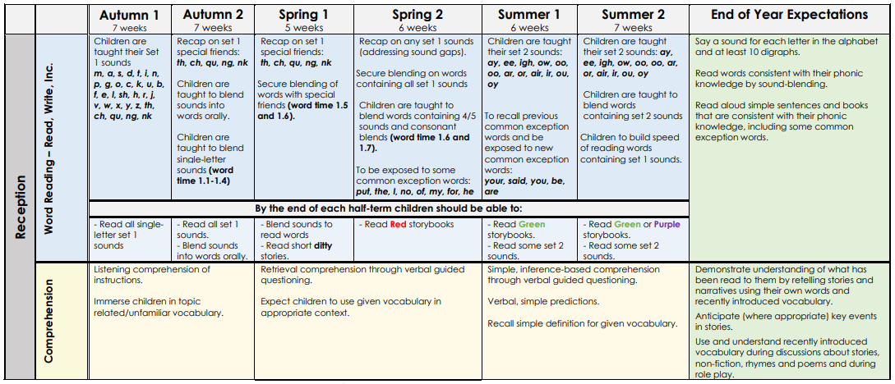
Literacy - Pathways to Write  Writing  Writing  Outcomes | Starting school  Autumn 1  Squiggle while you wriggle  Writing outcome:  To create different marks to represent lines, shapes and letters as a foundation for beginning to learn how to write letters in phonics. | 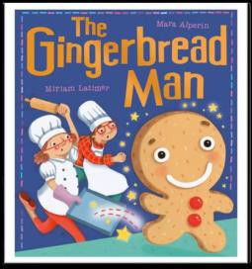  Fiction – Retell and Labels  Autumn 2  The Gingerbread Man  Writing outcome:  To create their own drawings to represent the story and orally  retell it. Pupil’s drawings will be labelled with marks appropriate to their development stage. | 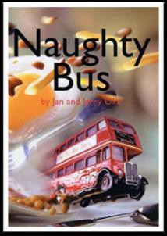  Non-fiction - Recount  Spring 1  Naughty Bus  Writing outcome:  To write a recount of the adventures of Naughty Bus and where he went. | 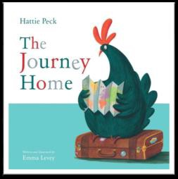  Fiction – adventure story  Spring 2  The Journey Home  Writing outcome:  To write their own re- telling of the story. | 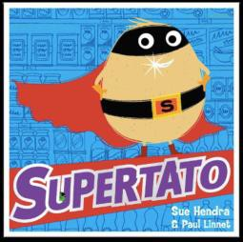  Non-fiction – Poster  Summer 1 Supertato  Writing outcome:  A wanted poster with character description. | 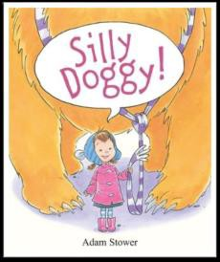  Fiction – Friendship Story  Summer 2  Silly Doggy  Writing outcome:  To orally retell the story.  To write a shortened version of the story.
WOW! Starters. | Wow Starter:  Pupils will follow music to the hall where they will dance, make patterns using flappers and then squiggle their dance on to paper using thick crayons on large pieces of paper. | Wow Starter:  Pupils follow small flour footprints into the classroom that  eventually lead up to various ingredients for making gingerbread. | Wow Starter:  A present arrives wrapped up for the class to open. It’s a toy London bus. | Wow Starter:  Pupils enter the classroom and find out that they have had ‘visitors’.  The visitors have left trails of different animal footprints around the classroom, leading to an old style suitcase. What’s in the suitcase? | Wow Starter:  In the builder’s tray have a large block of ice with peas frozen in the centre. Attached to the ice, place a note asking the children to free the peas. Or, place vegetables stuck with tape or string all over the classroom for the children to free. | Wow Starter:  Ask the head teacher to come into the classroom to explain that an animal has been rummaging around in the school bins and made a real mess. Have a picture for evidence for the pupils.
 | Dominant hand, tripod grip, mark making, Emergent writing.  Write some or all of own name.  Introduce the Message centre | Pencil grip.  Regular Name writing, labelling using initial sounds, story scribing. Application of phonics taught so far Message Centre | Pencil grip. Application of phonics taught so far Emergent writing celebrated  Tricky word work Message Centre Letter formation practise in family groups | Letter formation practise in family groups.  Tricky word work  Use known sound – letter correspondences Message Centre | Upper and lower case letter formation practise  Use known sound – letter correspondences  Full stops and capital letters awareness Tricky word work Message Centre | Upper and lower case letter formation practise  Use known sound – letter correspondences  Full stops and capital letters awareness  Re-read writing to check it makes sense Tricky word work
Progression into Year 1 | Spelling:  Spell most words containing each of the 40+ phonemes  Spell most common exception words Spell most days of the week  Spell most of the sounds taught in year 1 (English Appendix Spelling)  Spell words with adjacent consonants  Add suffixes to verbs where no change is needed in the spelling of root words (e.g. helping  helped, helper) and –est where no change is needed in the spelling of the root word  Use prefix words starting with un and understand how it changes the meaning (e.g. unkind,  undoing)  Begin to use regular plural noun suffixes – s/es (e.g. dog, dogs, wish, wishes) |  |  | Grammar and Punctuation:  Join words together to make a coherent sentence  Leave spaces between words  Join words and clauses using and can separate words in writing using spaces most of the time  Use capital letters for names of people, some places, some days of the week and the personal pronoun I  mostly correctly  Use some capital letters, full stops, question marks and exclamation marks to demarcate sentences with  increasing accuracy mostly correctly  Understand and use specific Y1 terminology (letter, capital letter, word, singular, plural, sentence,  punctuation, full stop, question mark, exclamation mark)
 | Composition:  Draw upon what they have read  Orally rehearse most sentences before writing them  Sequence sentences to form short narratives  Read their writing aloud clearly enough to be heard by their peers and the teacher |  |  | Evaluate and edit:  Discuss what has been written with a teacher/other pupils  Re-read what they have written to check it makes sense  Change some errors with support and some independently
Handwriting:
Sit correctly at a table, holding the pencil comfortably and correctly
Form lower case letters in the right direction, starting and finishing in the right place
Form capital letters and digits 0 – 9
Begin to understand which letters belong to which handwriting ‘families’ (i.e. letters
that are formed in similar ways)
 | Autumn 1 | Autumn 2 | Spring 1 | Spring 2 | Summer 1 | Summer 2
General Themes | All about me | Let’s tell a story | Journeys | Eggs, eggs, eggs! | Superheroes | All creatures great and small
Mathematics (White Rose Maths) | Developing a strong grounding in number is essential so that all children develop the necessary building blocks to excel mathematically. Children should be able to count confidently, develop a deep understanding of the numbers to 10, the relationships between them and the patterns within those numbers. By providing frequent and varied opportunities to build and apply this understanding -such as using manipulatives, including small pebbles and tens frames for organising counting - children will develop a secure base of knowledge and vocabulary from which mastery of mathematics is built. In addition, it is important that the curriculum includes rich opportunities for children to develop their spatial reasoning skills across all areas of mathematics including shape, space and measures. It is important that children develop positive attitudes and interests in mathematics, look for patterns and relationships, spot connections, ‘have a go’, talk to adults and peers about what they notice and not be afraid to make mistakes.
 | 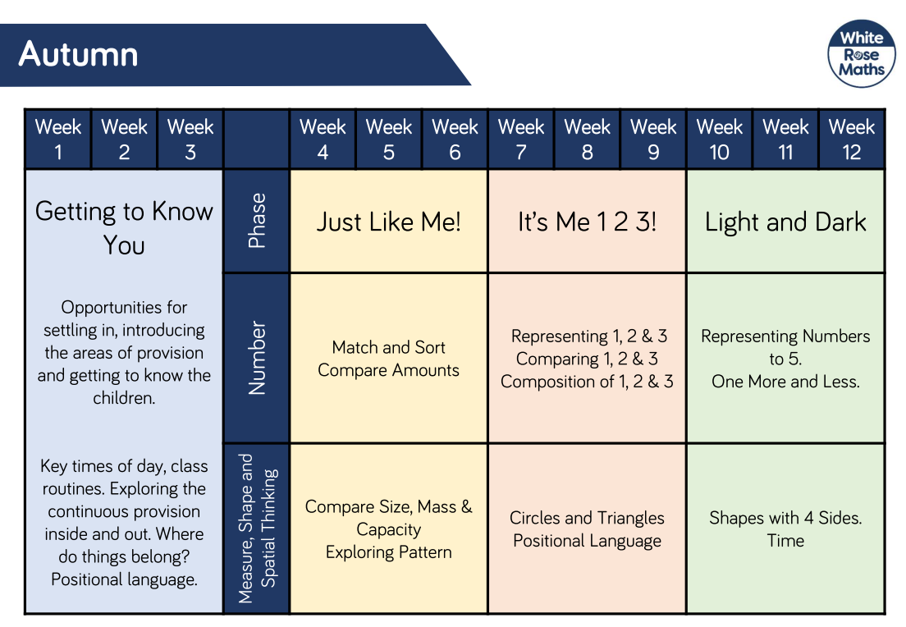 |  | 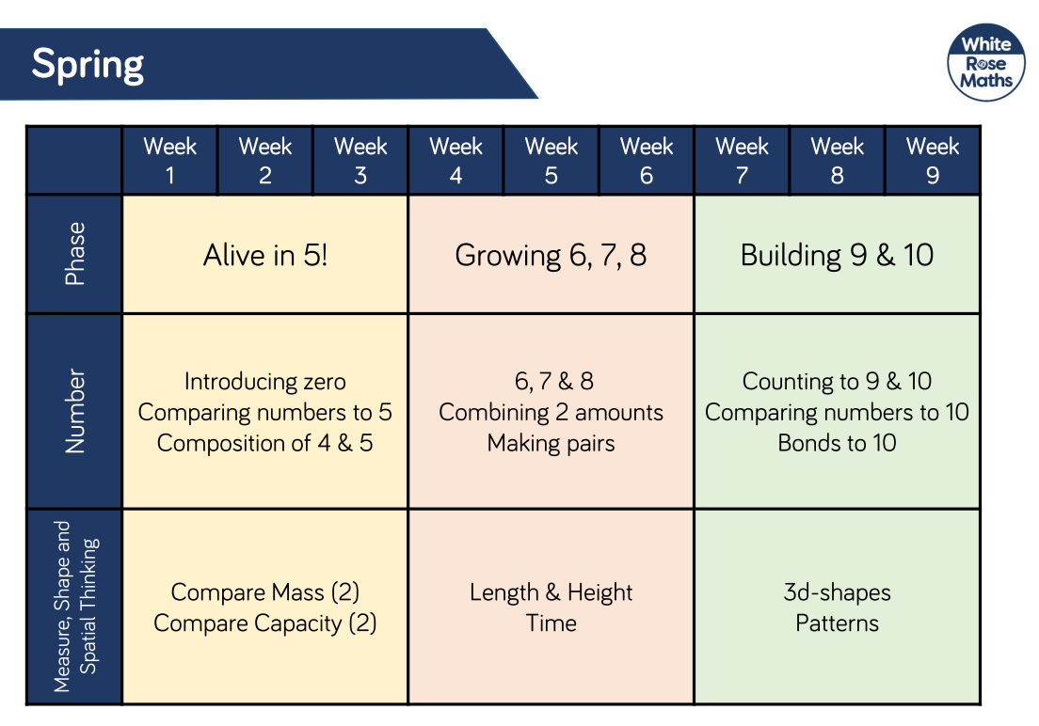 |  | 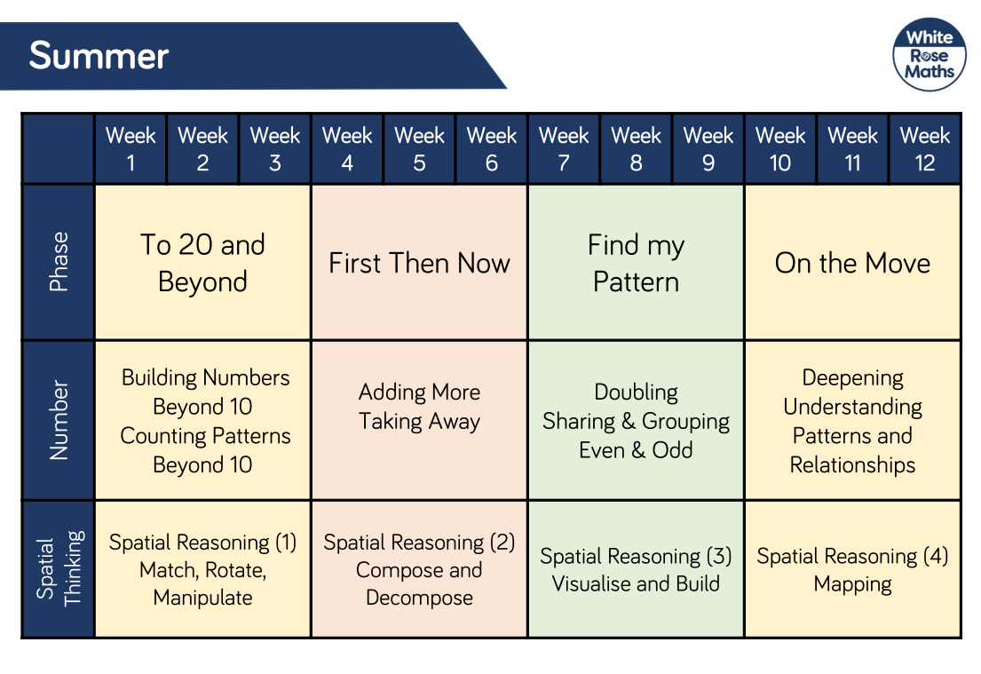
Progression into Year 1 | Number and place value: count to and across 100, forwards and backwards, beginning with 0 or 1, or from any given number count, read and write numbers to 100 in numerals; count in multiples of 2s, 5s and 10s given a number, identify 1 more and 1 less identify and represent numbers using objects and pictorial representations including the number line, and use the language of: equal to, more than, less than (fewer), most, least read and write numbers from 1 to 20 in numerals and words |  |  | Addition and Subtraction: read, write and interpret mathematical statements involving addition (+), subtraction (−) and equals (=) signs represent and use number bonds and related subtraction facts within 20 add and subtract one-digit and two-digit numbers to 20, including 0 solve one-step problems that involve addition and subtraction, using concrete objects and pictorial representations, and missing number problems such as 7 = ? − 9
 | Multiplication and Division: solve one-step problems involving multiplication and division, by calculating the answer using concrete objects, pictorial representations and arrays with the support of the teacher |  |  | Fractions: recognise, find and name a half as 1 of 2 equal parts of an object, shape or quantity recognise, find and name a quarter as 1 of 4 equal parts of an object, shape or quantity
 | Measurement:  Compare, describe and solve practical problems for:  Lengths and heights [for example, long/short, longer/shorter, tall/short, double/half]  Mass/weight [for example, heavy/light, heavier than, lighter than] capacity and volume [for example, full/empty, more than, less than, half, half full, quarter]  Time [for example, quicker, slower, earlier, later]  Measure and begin to record the following:  Lengths and heights  Mass/weight  Capacity and volume  Time (hours, minutes, seconds)  Recognise and know the value of different denominations of coins and notes  Sequence events in chronological order using language [for example, before and after, next, first, today, yesterday, tomorrow, morning, afternoon and evening] recognise and use language relating to dates, including days of the week, weeks, months and years  Tell the time to the hour and half past the hour and draw the hands on a clock face to show these times |  |  | Geometry: recognise and name common 2-D and 3-D shapes, including:  2-D shapes [for example, rectangles (including squares), circles and triangles]  3-D shapes [for example, cuboids (including cubes), pyramids and spheres]  Describe position, direction and movement, including whole, half, quarter and three-quarter turns

 | Autumn 1 | Autumn 2 | Spring 1 | Spring 2 | Summer 1 | Summer 2
Additional UTW Themes | My Family  Harvest  Seasonal changes – Autumn  Pumpkins | Bonfire Night  Light and dark  Christmas | Chinese New Year  China  Maps  Vehicles from the past | Science Week  Trip to Imagine That!  Seasonal changes - Spring | Occupations  Plants and growing  Pond dipping | Minibeasts
Understanding the World  People, culture & Communities  The natural world | Understanding the world involves guiding children to make sense of their physical world and their community. The frequency and range of children’s personal experiences increases their knowledge and sense of the world around them – from visiting parks, libraries and museums to meeting important members of society such as police officers, nurses and firefighters. In addition, listening to a broad selection of stories, non-fiction, rhymes and poems will foster their understanding of our culturally, socially, technologically and ecologically diverse world. As well as building important knowledge, this extends their familiarity with words that support understanding across domains. Enriching and widening children’s vocabulary will support later reading comprehension.
 | Identifying their family.  Commenting on photos of their family; naming who they can see and of what relation they are to them.  Can talk about what they do with their family?  Can draw similarities and make comparisons between other families?  Name and describe people who are familiar to them. Read fictional stories about families and start to tell the difference between real and fiction. Talk about members of their immediate family and community.  Navigating around our classroom and outdoor areas.  Talk about how they have changed from when they were a baby (past) Recognise what we are good at now (present)  Understanding how vegetables grow.  Looking at seeds.  Life cycle of a pumpkin.  Change in living things – Changes in the leaves, weather, seasons.  Provide opportunities for children to note the weather. | Listening to stories and placing events in chronological order.  Show photos of how Christmas used to be celebrated in the past.  Nocturnal animals.  Listen out for children’s discussion between themselves regarding their experience of past family celebrations.  Learn about different world faith celebrations – Diwali & Hannukah  Use images, video clips, shared texts and other resources to bring the wider world into the classroom.  Listen to what  Explore the world around us and see how it changes as we enter Winter.  Experience a snow day! | Use images, video clips, shared texts and other resources to bring the wider world into the classroom.  Listen to what children say about what they see.  Use the Bee-Bots.  Use Bee-Bots on simple maps. Encourage the children to use navigational language.  Maps of local area Comparing places UK & China – how are they similar/different?  Finding where UK is on a world map.  Where is China?  Share non-fiction texts that offer an insight into vehicles from the past, compare to now, the future.  Listen to children communicate their understanding of their own environment and contrasting environments through play.  Experiencing different cultures and food – tasting Chinese food.  Making red lanterns.  Listening to traditional Chinese stories.  Use texts and artefacts to explore a different country.  Understanding how Chinese New Year is celebrated here and in China.  Perform dragon dances.  Singing and dancing. | Draw children’s attention to the immediate environment, introducing and modelling new vocabulary where appropriate.  Practical investigations:  Materials: Floating / Sinking –  Magnetic / non-magnetic objects  Electrical circuits  Properties of materials  Balloon rockets/Archimedes bath  Encourage interactions with the outdoors to foster curiosity and give children freedom to touch, smell and hear the natural world around them during hands-on experiences.  Look for children incorporating their understanding of the seasons and weather in their play.  Change in living things – Changes in the leaves, weather, seasons.  Explore the world around us and see how it changes as we enter summer. | Introduce children to different occupations in school.  Who are our local superheroes?  Planting seeds – sunflower, beans, different vegetables.  Look after the plants in the vegetable garden  Use hand held tools to weed and plant a variety of plants.  What plants need to grow strong and healthy.  Investigate roots on a plant  Explore the school pond  Pond dipping  Catch and hold a common newt  Use a pond identification key to identify pond animals they catch. | Environments – Features of local environment  Listen to children describing and commenting on things they have seen whilst outside, including plants and animals.  After close observation, draw pictures of the natural world, including animals and plants.  Introduce the children to recycling and how it can take care of our world.  Look at what rubbish can do to our environment and animals.  Create opportunities to discuss how we care for the natural world around us. Building a ‘Bug Hotel’
 | Autumn 1 | Autumn 2 | Spring 1 | Spring 2 | Summer 1 | Summer 2
General Themes | All about me | Let’s tell a story | Journeys | Eggs, eggs, eggs! | Superheroes | All creatures great and small
Expressive arts and design  Children to explain their work to others. Children will have opportunities to learn and perform songs, nursery rhymes and poetry linked to their work / interests and passions.  Creating with Materials  Being imaginative and expressive | The development of children’s artistic and cultural awareness supports their imagination and creativity. It is important that children have regular opportunities to engage with the arts, enabling them to explore and play with a wide range of media and materials. The quality and variety of what children see, hear and participate in is crucial for developing their understanding, self-expression, vocabulary and ability to communicate through the arts. The frequency, repetition and depth of their experiences are fundamental to their progress in interpreting and appreciating what they hear, respond to and observe. Give children an insight into new musical worlds. Invite musicians in to play music to children and talk about it. Encourage children to listen attentively to music. Discuss changes and patterns as a piece of music develops.
 | Join in with songs; poems; rhymes  Autumn art - Experiment with paint media using a range of tools, e.g. different brush sizes, rollers and pads  Join in with role play games and use resources available for props; build models using construction equipment.  Self-portraits, family portraits, junk modelling, take picture of children’s creations and record them explaining what they did. | Listen to music and make their own dances in response.  Colour mixing – Kandinsky  Firework pictures, Christmas decorations, Christmas cards,  Learning Christmas songs  Role Play Celebrations & performing the Nativity Play in church  Teach children different techniques for joining materials, such as how to use adhesive tape and glue. | Journey maps  Construction – London  Junk model of a London red bus  Wheel weaving  Chinese New Year  Making lanterns, Chinese writing, puppet making, masks, Chinese music and singing.  Role-play  Acting out stories – the great race  Dragon dancing and music making  Holi | Make different textures; make patterns using different colours  Easter exploration - printing, rolling, patterns for Easter eggs.  Provide opportunities to work together to develop and realise creative ideas. Mixed media large scale pictures of animals that hatch out of eggs.  Mother’s Day crafts  Provide a wide range of props for play which encourage imagination. | Super hero masks & costumes – design, explore attaching materials  Painting super veggies/Evil pea/Supertato  Designing posters  Father’s Day crafts  Nature Mandalas  Sun flowers study – colour mixing, tweezer work, printing Artwork themed around Eric Carle  Eid al-Fitr | Puppet shows: Provide a wide range of props for play which encourage imagination.  Hapazome printing  Art work themed around minibeasts and frogs.
Progression into Year 1 | Mastering technique: Drawing  Experiment with a variety of media; pencils, rubbers, crayons,  pastels, felt tips, charcoal, pen, chalk. Begin to control the types of  marks made with the range of media. Draw on different surfaces  with a range of media. Develop a range of tone using a pencil and  use a variety of drawing techniques. |  |  | Texture, pattern, colour, line and tone  Investigate textures by describing, naming, rubbing, copying. Produce an expanding range of patterns and textures. Begin to understand how colours can link to moods and feelings in art.
 | Develop ideas - Master techniques  Take inspiration from the greats Start to record simple media explorations in a sketch book. |  |  | Taking inspiration from other artists  Look at and talk about own work Explore the work of a range of artists, craft makers and designers. Express their likes and dislikes.
 | Mastering technique: Painting  Experiment with paint media using a range of tools, e.g. different brush sizes, rollers and pads Explore techniques such as lightening and darkening paint without the use of black or white Begin to show control over the types of marks made Paint on different surfaces with a range of media Name the primary colours and start to mix a range of secondary colours, moving towards predicting resulting colours. |  |  | Mastering technique: Print-making  Explore printing simple pictures with a range of hard and soft materials e.g. cork, pen barrels, sponge Experience impressed printing: e.g. printing from objects Use equipment and media correctly and be able to produce a clean printed image Explore printing in relief: e.g. String and card Begin to identify forms of printing: Books, posters pictures, fabrics Use printmaking to create a repeating pattern.
Outdoor  Learning | Forest School:  Team Building Games  Exploring the school grounds  Ribbon wands and chalking  Observing creation  Treasure Hunts  Autumn crowns  Autumn walk  Shapes outdoors  Seasonal and weather changes  Make a Log dog  Forest animals and where they live -  badgers  Nocturnal animals  Clay Hedgehogs  Make forest pictures |  | Forest School:  Shelters  Fires for cooking  Contribute to fire lighting by gathering fuel  Roast marshmallows  Pancakes  Seasonal and weather changes  Encourage interactions with the outdoors to  foster curiosity and give children freedom to  touch, smell and hear the natural world  Hands-on experiences – use senses to  explore  Follow simple maps of the school grounds  Snow days  Make a Stickman  Build a den for an animal |  | Forest School:  Using tools  Introduction to tools - peelers (with gloves)  for whittling, hammers, mallets, trowels and  forks for planting.  Growing plants  Pond dipping  Bug hunting and investigating  Making a bug hotel  After close observation, draw pictures of the  natural world  Features of local environment  Planting seeds – sunflower, beans, different  vegetables  Happa Zoming
Enrichments | Autumn Term |  | Spring Term |  | Summer Term
 | Welcome Service in Church  Forest School  Harvest Festival  Health and Wellbeing Week  Dentist and Nurse Visit  Baking Gingerbread Men  Diwali  Pumpkin Week  Cooking Pumpkin Soup  Bonfire Night  Road Safety  Children in Need Day  Remembrance Sunday  Anti-bullying Week  Advent – Christingle  Hanukkah  Christmas - Nativity Play  Parents Christmas Craft Day  Cooking Peppermint Creams  Visit to Greenacres Farm Park with Y6 |  | Theatre Trip – Whole School  Forest School  Mothering Sunday  Planting Seeds  Science Week  Visit to Imagine That! Science & Discovery Centre  Internet Safety Week  Luna New Year  Shrove Tuesday/Ash Wednesday  Cooking pancakes  Lent  World book day  Harmony/Diversity Week  Holi  Sports/Comic Relief Day  Palm Sunday  Parents Easter Craft Day  Baking Easter nests  Easter Service in Church |  | Pentecost  Forest School  Eid al-Fitr  Visit – TBC on children’s interests/Topic  Father’s Day  Baking  Pond Dipping  Enterprise or Aspirations Week  First Class Assembly  Sports Day  Visit to Castle Park  Transition into Year 1
Early Learning Goals – for the end of the year - Holistic / best fit Judgement
